MongoDB Assignment

6) View list of available database

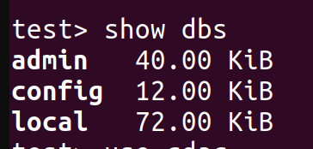

7) Create a new database named CDAC and connect to it

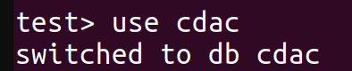

8) View list of available collections in CDAC database

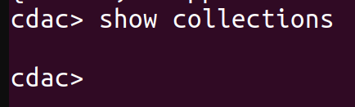

9) Create new collection by the name of Library
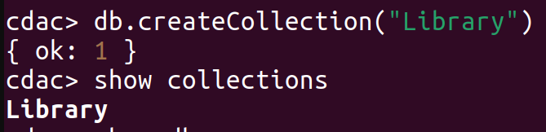

10) Insert the following document in the Library collection :-
title : ‘MongoDB programming’
author : ‘Sameer’, likes: 100

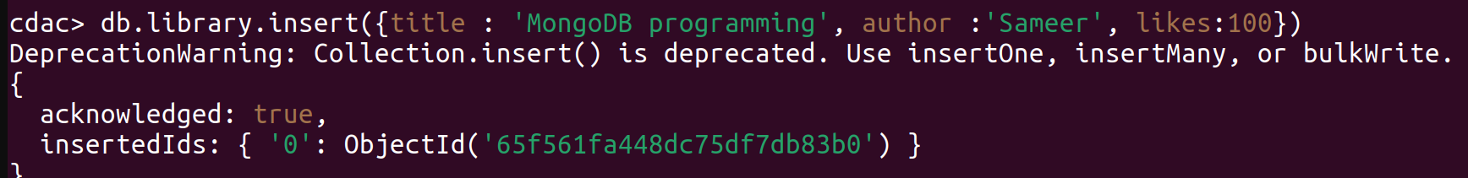

11) View the recently inserted document and note the _id field

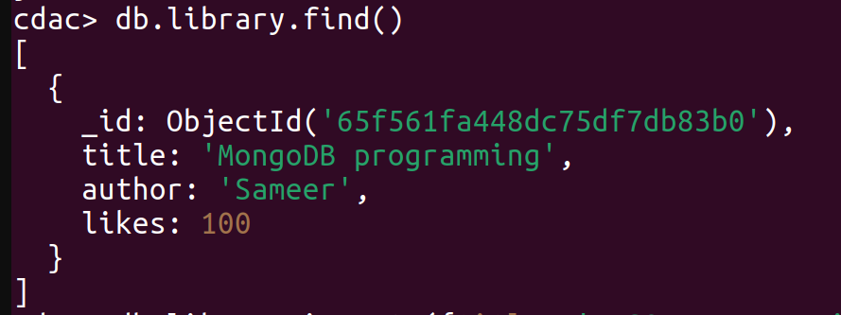
12) Insert another document in the Library collection as follow:-
title : ‘MySQL Programming’,
authors : [‘Jack’, ‘Jill’], likes : 200

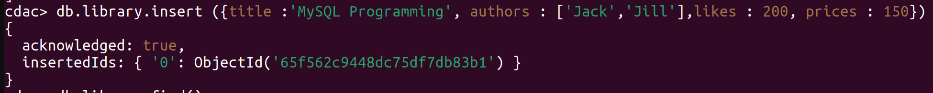
13) View the inserted documents
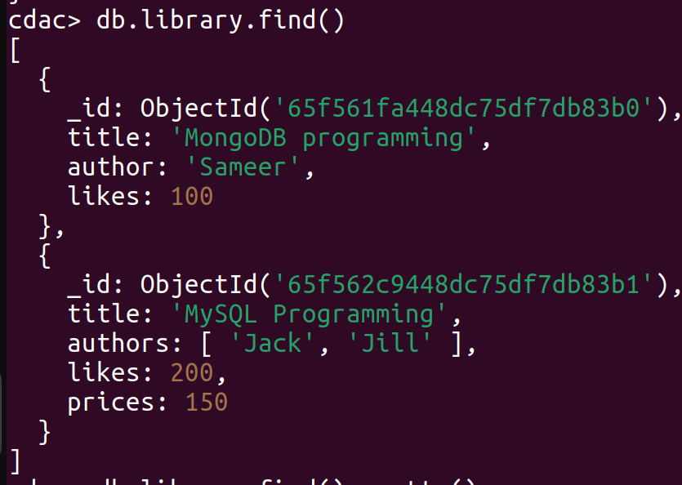

14) View only first inserted document

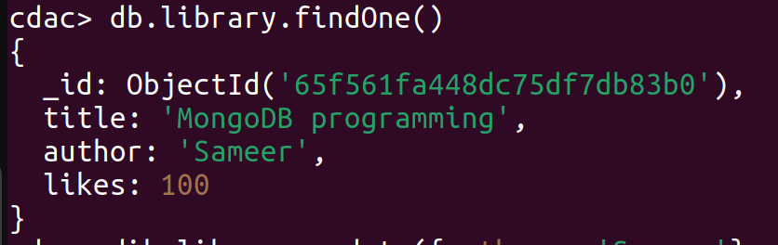
15) View the documents using the pretty( ) method

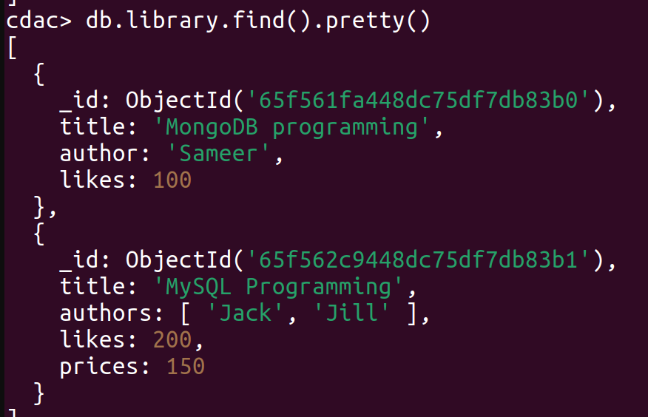
16) Update the document where author name Sameer and change it to Sameer Dehadrai

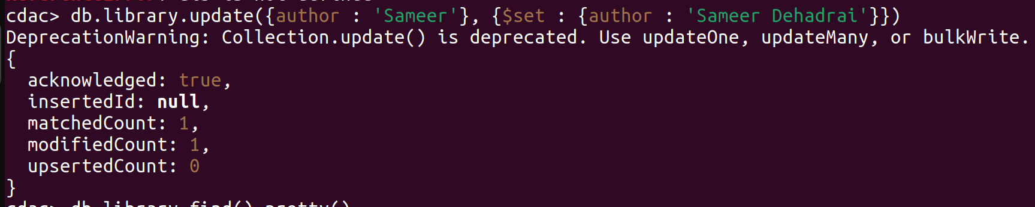

17) Delete all documents that have 100 likes

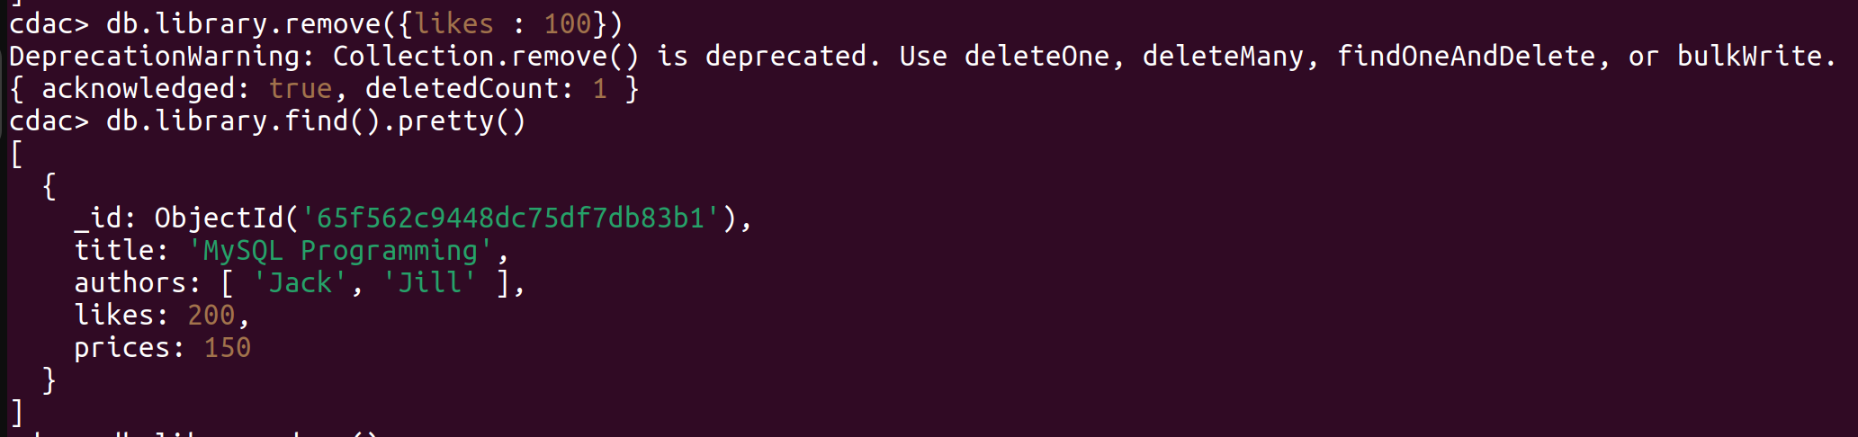

18) Drop Library collection

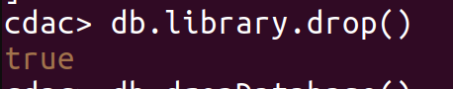

19) Drop the CDAC database

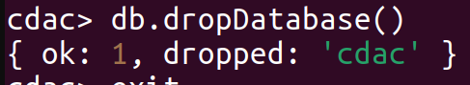

20) Exit from MongoDB shell

